Siva Mathiyazhagan, Ph.D.
Research Assistant Professor & Co-Director, SAFE Lab
School of Social Policy and Practice
University of Pennsylvania

Short Bio

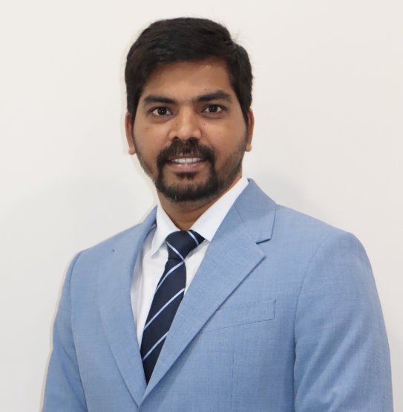
Dr. Siva Mathiyazhagan is a Research Assistant Professor at the School of Social Policy and Practice and Co-Director of the SAFE Lab at the University of Pennsylvania. He is a Senior Fellow at the Leonard Davis Institute of Health Economics at the University of Pennsylvania and a Pradeep Mehendiratta Fellow (2025-26) at the American Institute of Indian Studies. Dr. Mathiyazhagan is a global tech social work researcher and community practitioner. He co-designs and develops community-centered AI-supported technology products and tools for youth well-being and development. He co-creates tech social work policies and ethical considerations for Artificial Intelligence(AI), Machine Learning (ML), and Metaverse for social equity, and just and equitable Web3. Dr. Mathiyazhagan deploys a hybrid version of qualitative indigenous research methodologies and Contextual Analysis of Social Media (CASM) to understand youth expressions on social media in native/regional/hyper-local languages to prevent suicidal ideations and promote youth well-being. Dr. Mathiyazhagan is the Founder-Director of the youth-led non-profit Trust for Youth and Child Leadership (TYCL) International, based in Asia and the Americas. Dr. Mathiyazhagan serves as a TYCL representative to the United Nations. Dr. Mathiyazhagan was an RSM Assembly Fellow (2022-23) and faculty associate at the Berkman Klein Center for Internet & Society, Harvard University. Dr. Mathiyazhagan was a postdoctoral research scientist and lecturer at the School of Social Work at Columbia University.
Social Media: https://www.linkedin.com/in/siva-mathiyazhagan-58552537

